**Experiment 5: Reduction of *p*-Nitrophenol to *p*-Aminophenol**

**Name:** Vidhi Shah

**Reg. No.:** 21BCE1297

**Slot:** L11-L12

**Date:** 09/11/21

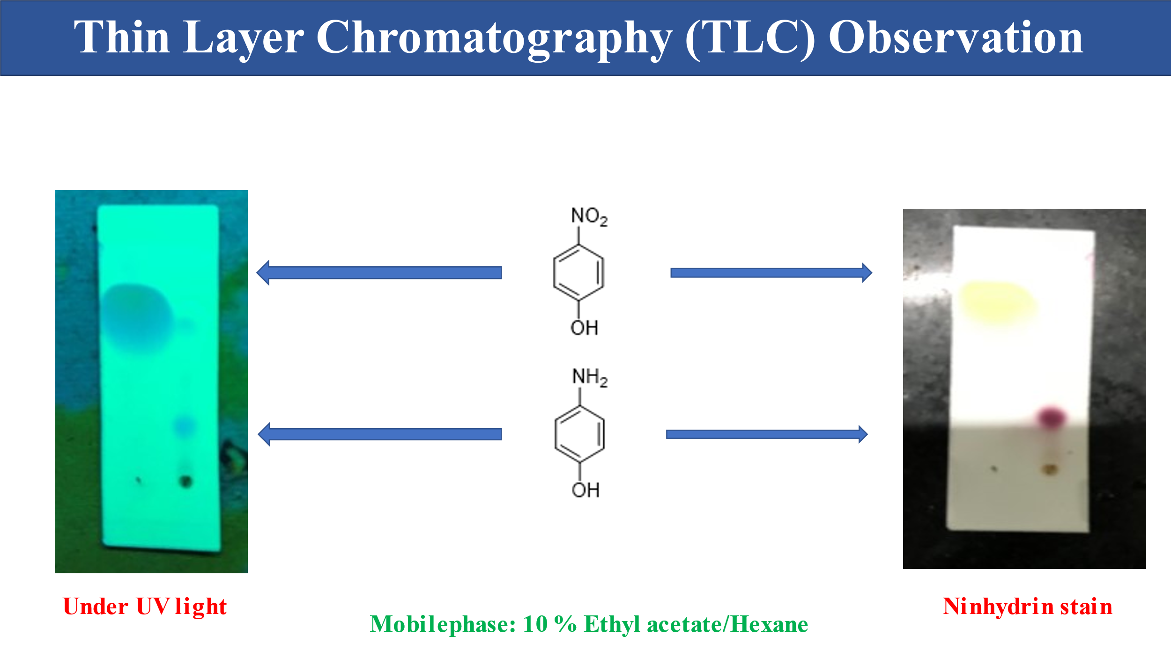

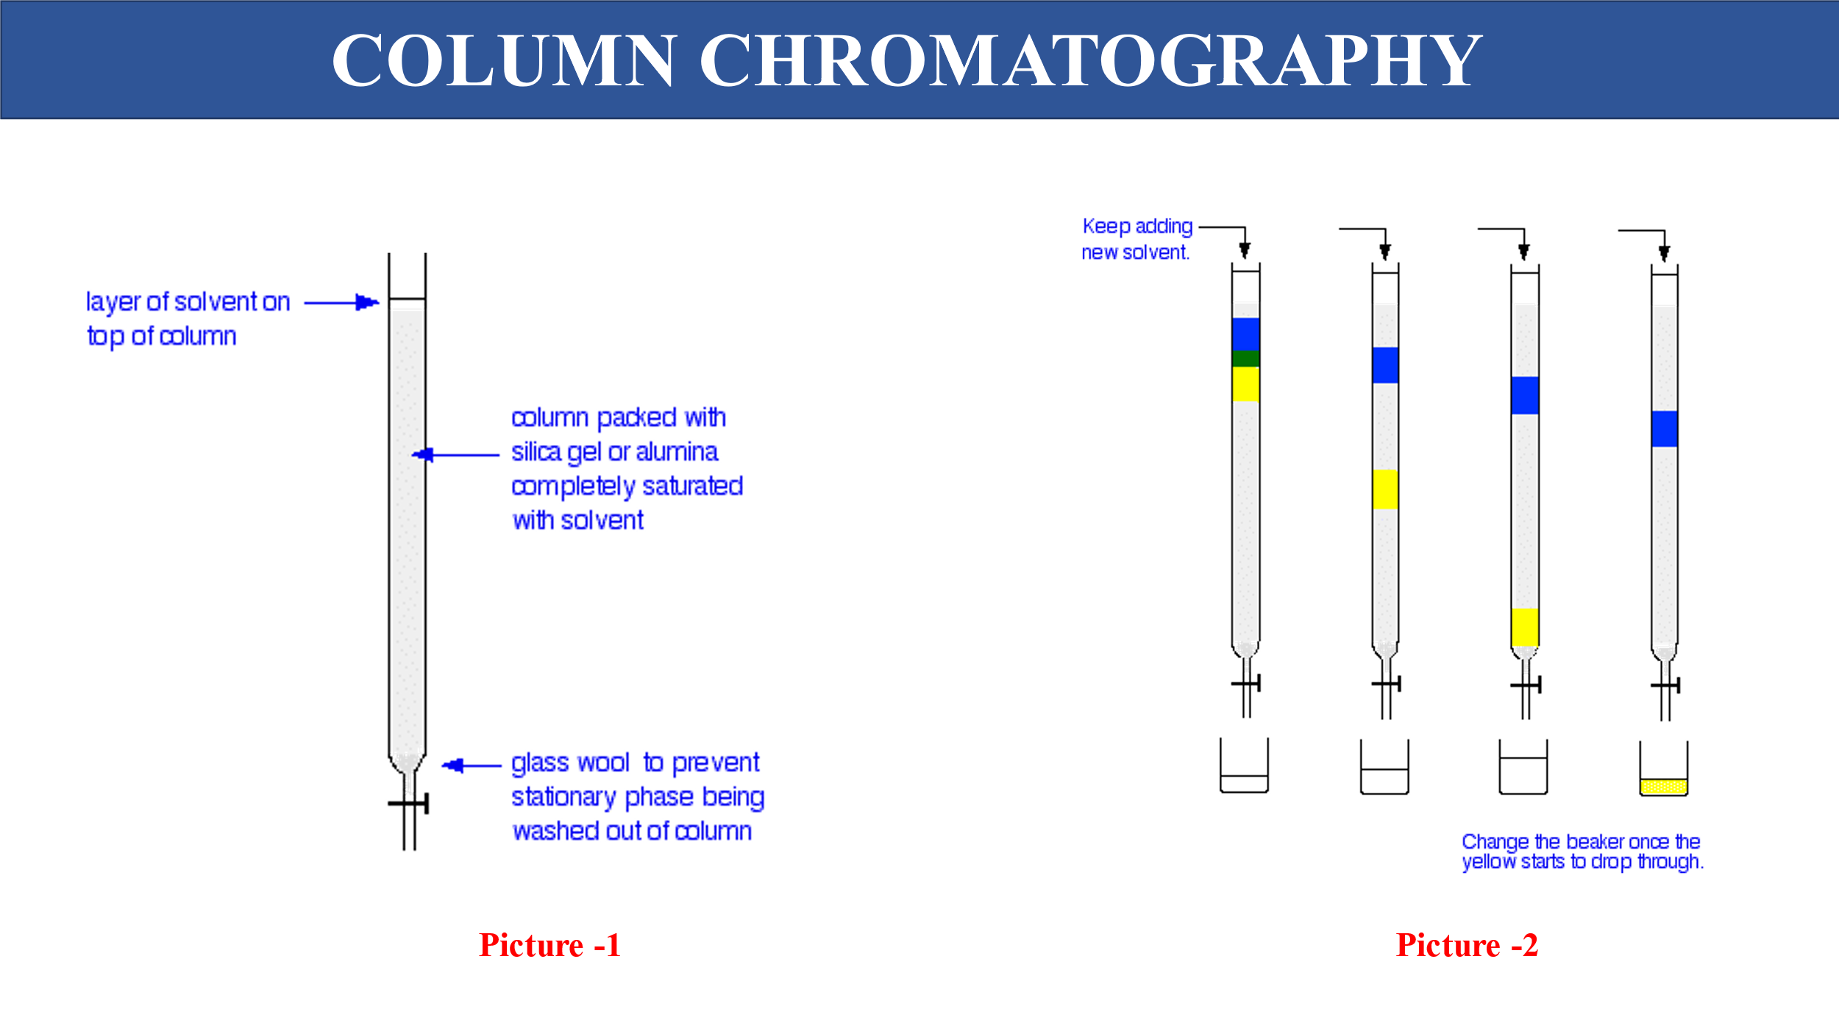

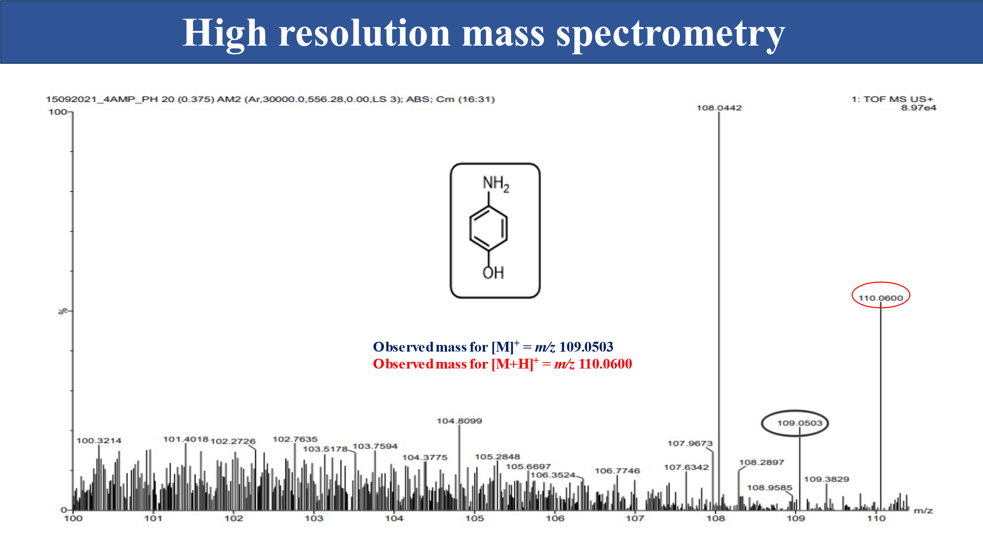

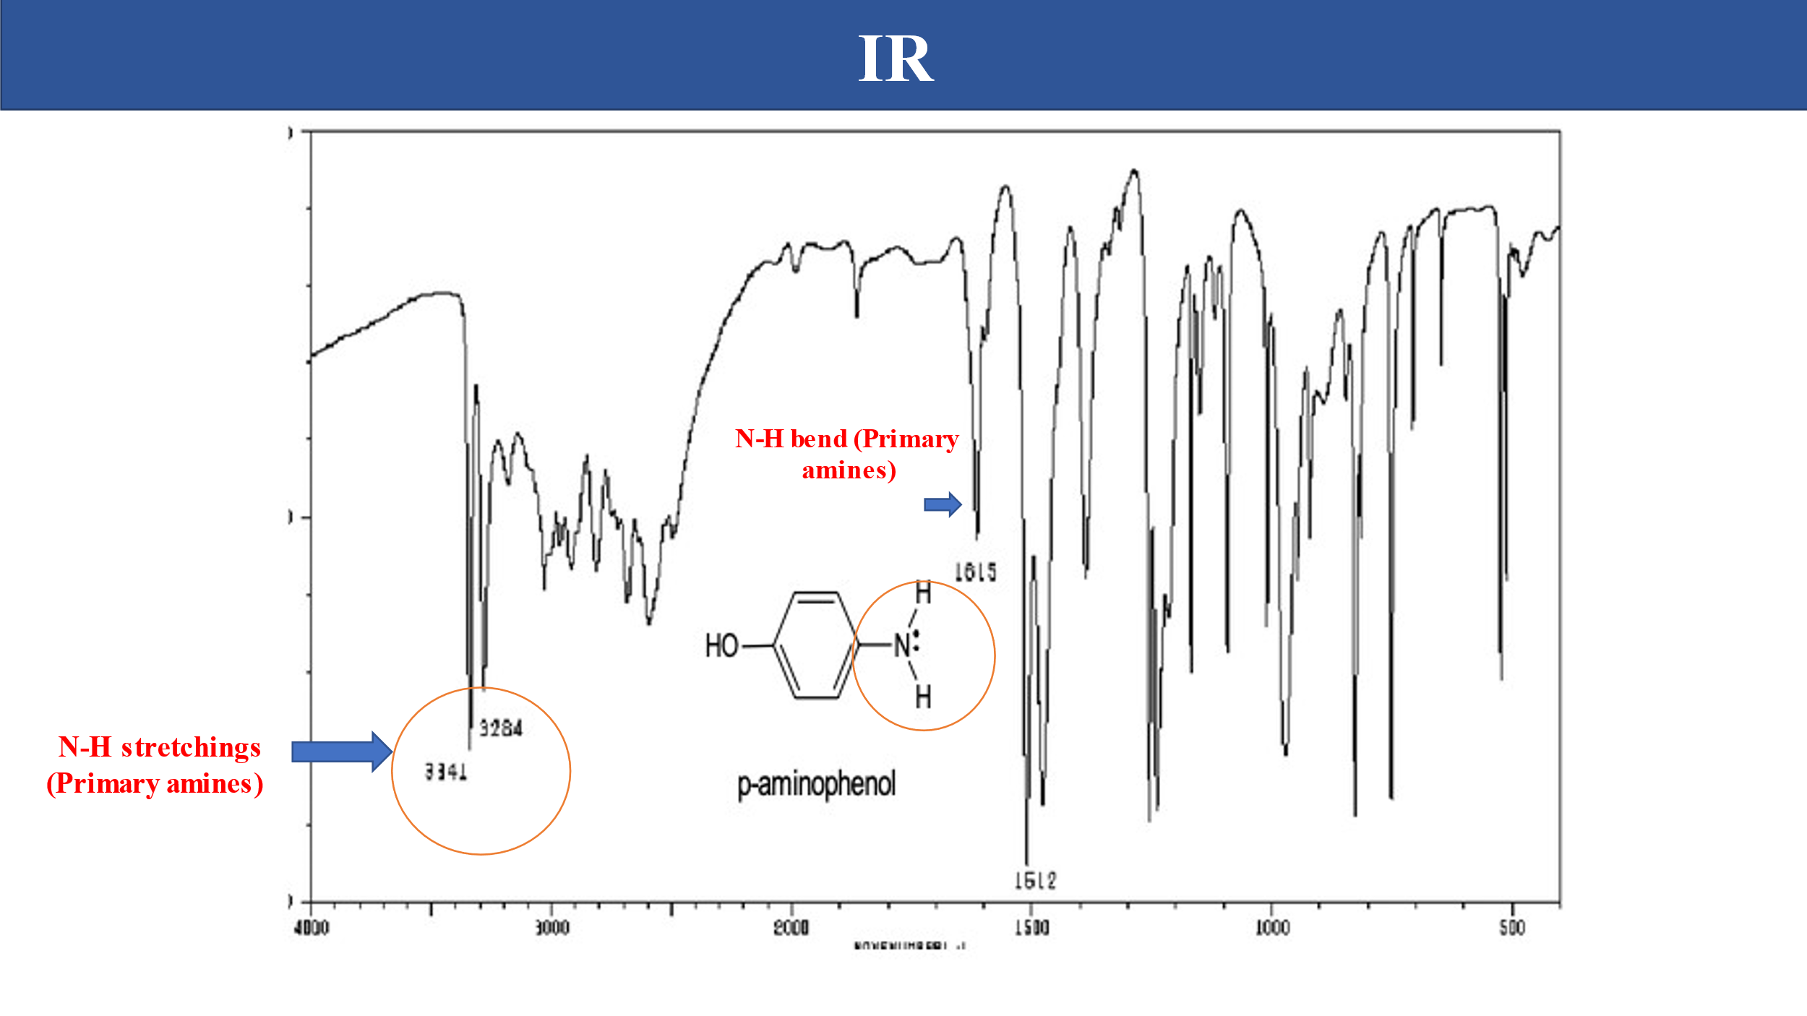

**Results:**



* Weight of the product calculated (Theoretical yield): 10.9 g
* Weight of the product obtained by the experiment (practical yield) = 9.1 g

**% Yield = x 100**

**%Yield** = x 100

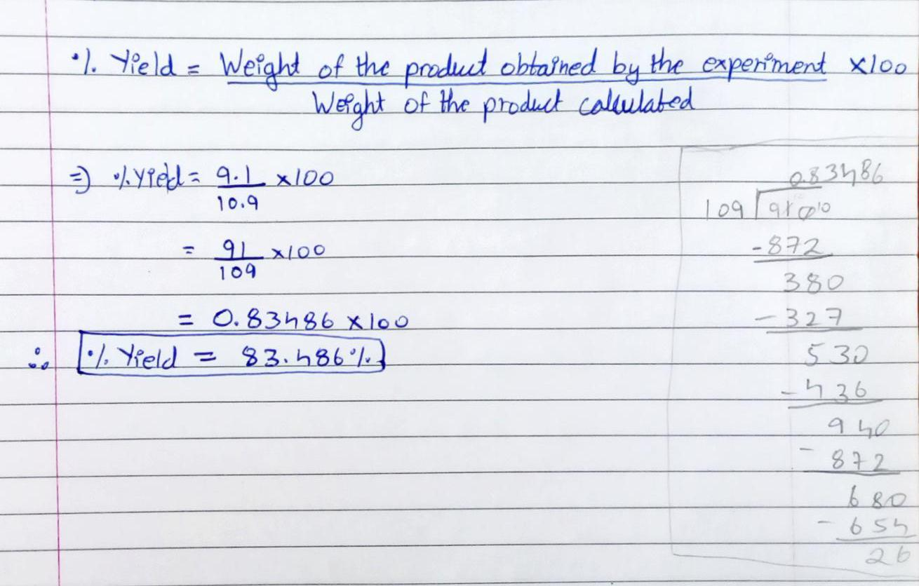**%Yield** = 0.83486 x 100

**%Yield = 83.486%**